Practical-2

AIM : Introduction to reproducible Machine Learning Operations

The aim of the practial is to get the hands-on experience of reproducing the machine learning operations at each stage. Student needs to apply the following steps in the practical.

**Step 1 :**

Ensure that the numpy, scikit learn, and matplotlib libraries are available in your system. Create the requirements.txt file and make a note of the versions of these libraries.

**To check the Versions of Libraries** :

pip show numpy

pip show scikit-learn

pip show matplotlib

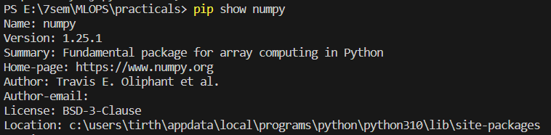 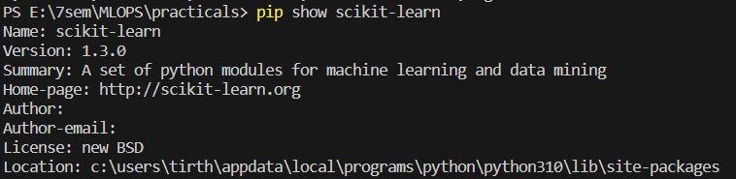 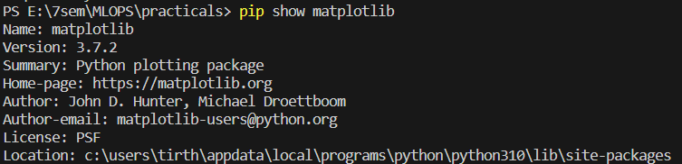

**Create requirements.txt:**

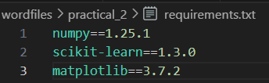

**Step 2 :**

1. **Import the data and scale it using StandardScaler:**

import numpy as np

from sklearn.preprocessing import StandardScaler

import joblib

# Load the data from sample.csv using np.genfromtxt

data = np.genfromtxt('sample.csv', delimiter=',')

# # Load the data from Sample.txt

# data = np.loadtxt('sample.csv')

# Create a StandardScaler object and fit_transform the data

scaler = StandardScaler()

scaled_data = scaler.fit_transform(data)

# Store the scaler object for reproducibility

joblib.dump(scaler, 'scaler_object.joblib')

# Now scaled_data contains the normalized dataset

1. **Splitting the normalized data:**

from sklearn.model_selection import train_test_split

# Split the data into training and testing sets

train_data, test_data = train_test_split(scaled_data, test_size=0.2, random_state=42)

# train_data and test_data now contain the training and testing datasets

1. **Storing the snapshot of the data as a numpy file:**

# Save the datasets as numpy files

np.save('train_data.npy', train_data)

np.save('test_data.npy', test_data)

**Step 3 :**

Apply the linear regression algorithm on the dataset and assess the prediction on the test dataset.

**a) Store the trained model into the local file system to ensure the reproducibility of the**

**prediction. Import the model and the test dataset into other python file. Check whether the same prediction is obtained in the latter case.**

from sklearn.linear_model import LinearRegression

import joblib

# Assume you already have the train_data and test_data loaded

# Separate features and target variable

X_train = train_data[:, :-1]

y_train = train_data[:, -1]

# Create and train the linear regression model

model = LinearRegression()

model.fit(X_train, y_train)

# Assess the prediction on the test dataset

X_test = test_data[:, :-1]

y_test = test_data[:, -1]

# Make predictions

predictions = model.predict(X_test)

# Store the trained model for reproducibility

joblib.dump(model, 'linear_regression_model.joblib')

# Now, in another Python file, you can load the model and test data for prediction

# Load the model

loaded_model = joblib.load('linear_regression_model.joblib')

# Make predictions on the test data

loaded_predictions = loaded_model.predict(X_test)

# Check if the predictions are the same

if np.array_equal(predictions, loaded_predictions):

    print("Output : Predictions match!")

else:

    print("Output : Predictions differ!")

**Output :**

